西 南 石 油 大 学 实 验 报 告

课 程 | 神经网络与深度学习导论 | 实验项目 | 实验四 深度学习应用 |  | 成 绩
专业年级 | 计算机科学与技术2022级 | 学 号 | 202231060435 | 指导教师 | 郑 津
姓 名 | 王磊 | 同组姓名 |  |  | 日 期
一、实验目的
本项目的目标为：学生在深入理解深度学习基本理论及方法的基础上，具有基于深度学习技术建立模型研究实现典型人工智能任务，并对其进行性能分析的能力。通过本实验环节的训练，使学生进一步熟悉并掌握基于飞桨平台的使用方法，加深对深度学习基础理论的理解，强化编程技能，培养动手实践和一定的创新能力。
支撑专业实践能力培养目标中的专业核心能力5：具备大数据分析与挖掘能力，掌握各种数据分析技术和手段，对数据进行初步建模，并能利用统计建模和机器学习的基本理论、方法，对数据进行深度分析和产品化开发。
支撑专业实践能力培养目标中的综合创新能力8：具备大数据分析与挖掘能力，掌握各种数据分析技术和手段，具备广泛的数据应用视野，能够胜任大数据商务与金融、医疗、能源等各类相关应用领域的多层次综合创新工作。
二、实验内容
1. 目标检测
2. 机器翻译
三、实验过程
1.目标检测实验代码
!cd /home/aistudio/data/data4379 && unzip -o -q pascalvoc.zip
print("load success")
!mkdir pretrained-model
!mkdir ssd-model
!cp data/data7948/mobilenet_v1_imagenet.zip pretrained-model/
!cd pretrained-model && unzip mobilenet_v1_imagenet.zip
!cd pretrained-model && mv mobilenet_v1_imagenet/* . && rm -r mobilenet_v1_imagenet && rm mobilenet_v1_imagenet.zip
## 自行设定合适的num_epochs数值，完成训练。

from __future__ import absolute_import
from __future__ import division
from __future__ import print_function
import os
import uuid
import numpy as np
import time
import six
import math
import paddle
import paddle.fluid as fluid
import logging
import xml.etree.ElementTree
import codecs

from paddle.fluid.initializer import MSRA
from paddle.fluid.param_attr import ParamAttr
from PIL import Image, ImageEnhance, ImageDraw

logger = None
train_parameters = {
"input_size": [3, 300, 300], # 图片的维度
"class_dim": -1, #分类数
"label_dict": {}, # 存放标签字典
"image_count": -1, #训练图片数量
"log_feed_image": False,
"pretrained": True, #是否使用预训练的模型
"pretrained_model_dir": "./pretrained-model", #预训练的mobilenet模型存放路径
"save_model_dir": "./ssd-model", #训练后的模型保存路径
"model_prefix": "mobilenet-ssd", #模型路径前缀
"data_dir": "/home/aistudio/data/data4379/pascalvoc", # 数据集解压后存放的目录
"mean_rgb": [127.5, 127.5, 127.5], # 常用图片的三通道均值，通常来说需要先对训练数据做统计，此处仅取中间值
"file_list": "train.txt", # 存放训练集图片和标注文件的对应关系
"mode": "train", # train 或者 test
"multi_data_reader_count": 1,
"num_epochs": 1, ## 训练轮数
"train_batch_size": 64, # 训练集batch_size大小
"use_gpu": False, # 是否使用gpu
"apply_distort": True,
"apply_expand": True,
"apply_corp": True,
"image_distort_strategy": { #图像增强的一堆参数
"expand_prob": 0.5,
"expand_max_ratio": 4,
"hue_prob": 0.5,
"hue_delta": 18,
"contrast_prob": 0.5,
"contrast_delta": 0.5,
"saturation_prob": 0.5,
"saturation_delta": 0.5,
"brightness_prob": 0.5,
"brightness_delta": 0.125
},
"rsm_strategy": { #一种自适应学习率的方法
"learning_rate": 0.001,
"lr_epochs": [40, 60, 80, 100],
"lr_decay": [1, 0.5, 0.25, 0.1, 0.01],
},
"momentum_strategy": { #暂未使用
"learning_rate": 0.1,
"decay_steps": 2 ** 7,
"decay_rate": 0.8
},
"early_stop": {
"sample_frequency": 50,
"successive_limit": 3,
"min_loss": 1.28, #最小的损失
"min_curr_map": 0.86 #最小的mAP值
}
}
class MobileNetSSD:
def __init__(self):
pass

def conv_bn(self,
input,
filter_size,
num_filters,
stride,
padding,
num_groups=1,
act='relu',
use_cudnn=True):
parameter_attr = ParamAttr(learning_rate=0.1, initializer=MSRA())
conv = fluid.layers.conv2d(
input=input,
num_filters=num_filters,
filter_size=filter_size,
stride=stride,
padding=padding,
groups=num_groups,
act=None,
use_cudnn=use_cudnn,
param_attr=parameter_attr,
bias_attr=False)
return fluid.layers.batch_norm(input=conv, act=act)

def depthwise_separable(self, input, num_filters1, num_filters2, num_groups, stride, scale):
depthwise_conv = self.conv_bn(
input=input,
filter_size=3,
num_filters=int(num_filters1 * scale),
stride=stride,
padding=1,
num_groups=int(num_groups * scale),
use_cudnn=False)

pointwise_conv = self.conv_bn(
input=depthwise_conv,
filter_size=1,
num_filters=int(num_filters2 * scale),
stride=1,
padding=0)
return pointwise_conv

def extra_block(self, input, num_filters1, num_filters2, num_groups, stride, scale):
# 1x1 conv
pointwise_conv = self.conv_bn(
input=input,
filter_size=1,
num_filters=int(num_filters1 * scale),
stride=1,
num_groups=int(num_groups * scale),
padding=0)

# 3x3 conv
normal_conv = self.conv_bn(
input=pointwise_conv,
filter_size=3,
num_filters=int(num_filters2 * scale),
stride=2,
num_groups=int(num_groups * scale),
padding=1)
return normal_conv

def net(self, num_classes, img, img_shape, scale=1.0):
# 300x300
tmp = self.conv_bn(img, 3, int(32 * scale), 2, 1)
# 150x150
tmp = self.depthwise_separable(tmp, 32, 64, 32, 1, scale)
tmp = self.depthwise_separable(tmp, 64, 128, 64, 2, scale)
# 75x75
tmp = self.depthwise_separable(tmp, 128, 128, 128, 1, scale)
tmp = self.depthwise_separable(tmp, 128, 256, 128, 2, scale)
# 38x38
tmp = self.depthwise_separable(tmp, 256, 256, 256, 1, scale)
tmp = self.depthwise_separable(tmp, 256, 512, 256, 2, scale)

# 19x19
for i in range(5):
tmp = self.depthwise_separable(tmp, 512, 512, 512, 1, scale)
module11 = tmp
tmp = self.depthwise_separable(tmp, 512, 1024, 512, 2, scale)

# 10x10
module13 = self.depthwise_separable(tmp, 1024, 1024, 1024, 1, scale)
module14 = self.extra_block(module13, 256, 512, 1, 2, scale)
# 5x5
module15 = self.extra_block(module14, 128, 256, 1, 2, scale)
# 3x3
module16 = self.extra_block(module15, 128, 256, 1, 2, scale)
# 2x2
module17 = self.extra_block(module16, 64, 128, 1, 2, scale)
#生成SSD算法的候选框。从多个特征图中，进行预测分类边界框。
mbox_locs, mbox_confs, box, box_var = fluid.layers.multi_box_head(
inputs=[module11, module13, module14, module15, module16, module17], #输入变量列表
image=img, #输入图像数据
num_classes=num_classes, #类的数量
min_ratio=20, #生成候选框的最小比例
max_ratio=90, #生成候选框的最大比例
aspect_ratios=[[2.], [2., 3.], [2., 3.], [2., 3.], [2., 3.], [2., 3.]],#生成候选框的宽高比
base_size=img_shape[2], #300
offset=0.5, #候选框中心偏移
flip=True) #是否翻转宽高比

return mbox_locs, mbox_confs, box, box_var #返回gound_truth的位置（中心点的坐标、长、宽）、预测框对输入的置信度、候选框、方差

class sampler:
def __init__(self, max_sample, max_trial, min_scale, max_scale,
min_aspect_ratio, max_aspect_ratio, min_jaccard_overlap,
max_jaccard_overlap):
self.max_sample = max_sample
self.max_trial = max_trial
self.min_scale = min_scale
self.max_scale = max_scale
self.min_aspect_ratio = min_aspect_ratio
self.max_aspect_ratio = max_aspect_ratio
self.min_jaccard_overlap = min_jaccard_overlap
self.max_jaccard_overlap = max_jaccard_overlap

class bbox:
def __init__(self, xmin, ymin, xmax, ymax):
self.xmin = xmin
self.ymin = ymin
self.xmax = xmax
self.ymax = ymax
# 初始化train_train_parameters中的参数
def init_train_parameters():
file_list = os.path.join(train_parameters['data_dir'], "train.txt")
label_list = os.path.join(train_parameters['data_dir'], "label_list")
index = 0
with codecs.open(label_list, encoding='utf-8') as flist:
lines = [line.strip() for line in flist]
for line in lines:
train_parameters['label_dict'][line.strip()] = index
index += 1
train_parameters['class_dim'] = index
with codecs.open(file_list, encoding='utf-8') as flist:
lines = [line.strip() for line in flist]
train_parameters['image_count'] = len(lines)

#初始化日志记录相关参数
def init_log_config():
global logger
logger = logging.getLogger()
logger.setLevel(logging.INFO)
log_path = os.path.join(os.getcwd(), 'logs')
if not os.path.exists(log_path):
os.makedirs(log_path)
log_name = os.path.join(log_path, 'train.log')
fh = logging.FileHandler(log_name, mode='w')
fh.setLevel(logging.DEBUG)
formatter = logging.Formatter("%(asctime)s - %(filename)s[line:%(lineno)d] - %(levelname)s: %(message)s")
fh.setFormatter(formatter)
logger.addHandler(fh)
#为了更直观的看到训练样本的形态，增加打印图片，并画出bbox的函数
def log_feed_image(img, sampled_labels):
draw = ImageDraw.Draw(img)
target_h = train_parameters['input_size'][1]
target_w = train_parameters['input_size'][2]
for label in sampled_labels:
print(label)
draw.rectangle((label[1] * target_w, label[2] * target_h, label[3] * target_w, label[4] * target_h), None,
'red')
img.save(str(uuid.uuid1()) + '.jpg')
def bbox_area(src_bbox):
width = src_bbox.xmax - src_bbox.xmin
height = src_bbox.ymax - src_bbox.ymin
return width * height

def generate_sample(sampler):
scale = np.random.uniform(sampler.min_scale, sampler.max_scale)
aspect_ratio = np.random.uniform(sampler.min_aspect_ratio, sampler.max_aspect_ratio)
aspect_ratio = max(aspect_ratio, (scale ** 2.0))
aspect_ratio = min(aspect_ratio, 1 / (scale ** 2.0))

bbox_width = scale * (aspect_ratio ** 0.5)
bbox_height = scale / (aspect_ratio ** 0.5)
xmin_bound = 1 - bbox_width
ymin_bound = 1 - bbox_height
xmin = np.random.uniform(0, xmin_bound)
ymin = np.random.uniform(0, ymin_bound)
xmax = xmin + bbox_width
ymax = ymin + bbox_height
sampled_bbox = bbox(xmin, ymin, xmax, ymax)
return sampled_bbox

def jaccard_overlap(sample_bbox, object_bbox):
if sample_bbox.xmin >= object_bbox.xmax or \
sample_bbox.xmax <= object_bbox.xmin or \
sample_bbox.ymin >= object_bbox.ymax or \
sample_bbox.ymax <= object_bbox.ymin:
return 0
intersect_xmin = max(sample_bbox.xmin, object_bbox.xmin)
intersect_ymin = max(sample_bbox.ymin, object_bbox.ymin)
intersect_xmax = min(sample_bbox.xmax, object_bbox.xmax)
intersect_ymax = min(sample_bbox.ymax, object_bbox.ymax)
intersect_size = (intersect_xmax - intersect_xmin) * (intersect_ymax - intersect_ymin)
sample_bbox_size = bbox_area(sample_bbox)
object_bbox_size = bbox_area(object_bbox)
overlap = intersect_size / (sample_bbox_size + object_bbox_size - intersect_size)
return overlap

def satisfy_sample_constraint(sampler, sample_bbox, bbox_labels):
if sampler.min_jaccard_overlap == 0 and sampler.max_jaccard_overlap == 0:
return True
for i in range(len(bbox_labels)):
object_bbox = bbox(bbox_labels[i][1], bbox_labels[i][2], bbox_labels[i][3], bbox_labels[i][4])
overlap = jaccard_overlap(sample_bbox, object_bbox)
if sampler.min_jaccard_overlap != 0 and overlap < sampler.min_jaccard_overlap:
continue
if sampler.max_jaccard_overlap != 0 and overlap > sampler.max_jaccard_overlap:
continue
return True
return False

def generate_batch_samples(batch_sampler, bbox_labels):
sampled_bbox = []
index = []
c = 0
for sampler in batch_sampler:
found = 0
for i in range(sampler.max_trial):
if found >= sampler.max_sample:
break
sample_bbox = generate_sample(sampler)
if satisfy_sample_constraint(sampler, sample_bbox, bbox_labels):
sampled_bbox.append(sample_bbox)
found = found + 1
index.append(c)
c = c + 1
return sampled_bbox

def clip_bbox(src_bbox):
src_bbox.xmin = max(min(src_bbox.xmin, 1.0), 0.0)
src_bbox.ymin = max(min(src_bbox.ymin, 1.0), 0.0)
src_bbox.xmax = max(min(src_bbox.xmax, 1.0), 0.0)
src_bbox.ymax = max(min(src_bbox.ymax, 1.0), 0.0)
return src_bbox

def meet_emit_constraint(src_bbox, sample_bbox):
center_x = (src_bbox.xmax + src_bbox.xmin) / 2
center_y = (src_bbox.ymax + src_bbox.ymin) / 2
if center_x >= sample_bbox.xmin and \
center_x <= sample_bbox.xmax and \
center_y >= sample_bbox.ymin and \
center_y <= sample_bbox.ymax:
return True
return False

def transform_labels(bbox_labels, sample_bbox):
proj_bbox = bbox(0, 0, 0, 0)
sample_labels = []
for i in range(len(bbox_labels)):
sample_label = []
object_bbox = bbox(bbox_labels[i][1], bbox_labels[i][2], bbox_labels[i][3], bbox_labels[i][4])
if not meet_emit_constraint(object_bbox, sample_bbox):
continue
sample_width = sample_bbox.xmax - sample_bbox.xmin
sample_height = sample_bbox.ymax - sample_bbox.ymin
proj_bbox.xmin = (object_bbox.xmin - sample_bbox.xmin) / sample_width
proj_bbox.ymin = (object_bbox.ymin - sample_bbox.ymin) / sample_height
proj_bbox.xmax = (object_bbox.xmax - sample_bbox.xmin) / sample_width
proj_bbox.ymax = (object_bbox.ymax - sample_bbox.ymin) / sample_height
proj_bbox = clip_bbox(proj_bbox)
if bbox_area(proj_bbox) > 0:
sample_label.append(bbox_labels[i][0])
sample_label.append(float(proj_bbox.xmin))
sample_label.append(float(proj_bbox.ymin))
sample_label.append(float(proj_bbox.xmax))
sample_label.append(float(proj_bbox.ymax))
sample_label.append(bbox_labels[i][5])
sample_labels.append(sample_label)
return sample_labels

#裁剪图片
def crop_image(img, bbox_labels, sample_bbox, image_width, image_height):
sample_bbox = clip_bbox(sample_bbox)
xmin = int(sample_bbox.xmin * image_width)
xmax = int(sample_bbox.xmax * image_width)
ymin = int(sample_bbox.ymin * image_height)
ymax = int(sample_bbox.ymax * image_height)
sample_img = img.crop((xmin, ymin, xmax, ymax))
sample_labels = transform_labels(bbox_labels, sample_bbox)
return sample_img, sample_labels
#调整图片大小
def resize_img(img, sampled_labels):
target_size = train_parameters['input_size']
ret = img.resize((target_size[1], target_size[2]), Image.ANTIALIAS)
return ret

#图像增强，亮度调整
def random_brightness(img):
prob = np.random.uniform(0, 1)
if prob < train_parameters['image_distort_strategy']['brightness_prob']:
brightness_delta = train_parameters['image_distort_strategy']['brightness_delta']
delta = np.random.uniform(-brightness_delta, brightness_delta) + 1
img = ImageEnhance.Brightness(img).enhance(delta)
return img

#图像增强，对比度调整
def random_contrast(img):
prob = np.random.uniform(0, 1)
if prob < train_parameters['image_distort_strategy']['contrast_prob']:
contrast_delta = train_parameters['image_distort_strategy']['contrast_delta']
delta = np.random.uniform(-contrast_delta, contrast_delta) + 1
img = ImageEnhance.Contrast(img).enhance(delta)
return img

#图像增强，饱和度调整
def random_saturation(img):
prob = np.random.uniform(0, 1)
if prob < train_parameters['image_distort_strategy']['saturation_prob']:
saturation_delta = train_parameters['image_distort_strategy']['saturation_delta']
delta = np.random.uniform(-saturation_delta, saturation_delta) + 1
img = ImageEnhance.Color(img).enhance(delta)
return img

#图像增强，色度调整
def random_hue(img):
prob = np.random.uniform(0, 1)
if prob < train_parameters['image_distort_strategy']['hue_prob']:
hue_delta = train_parameters['image_distort_strategy']['hue_delta']
delta = np.random.uniform(-hue_delta, hue_delta)
img_hsv = np.array(img.convert('HSV'))
img_hsv[:, :, 0] = img_hsv[:, :, 0] + delta
img = Image.fromarray(img_hsv, mode='HSV').convert('RGB')
return img

#概率的图像增强
def distort_image(img):
prob = np.random.uniform(0, 1)
# Apply different distort order
if prob > 0.5:
img = random_brightness(img)
img = random_contrast(img)
img = random_saturation(img)
img = random_hue(img)
else:
img = random_brightness(img)
img = random_saturation(img)
img = random_hue(img)
img = random_contrast(img)
return img

def expand_image(img, bbox_labels, img_width, img_height):
prob = np.random.uniform(0, 1)
if prob < train_parameters['image_distort_strategy']['expand_prob']:
expand_max_ratio = train_parameters['image_distort_strategy']['expand_max_ratio']
if expand_max_ratio - 1 >= 0.01:
expand_ratio = np.random.uniform(1, expand_max_ratio)
height = int(img_height * expand_ratio)
width = int(img_width * expand_ratio)
h_off = math.floor(np.random.uniform(0, height - img_height))
w_off = math.floor(np.random.uniform(0, width - img_width))
expand_bbox = bbox(-w_off / img_width, -h_off / img_height,
(width - w_off) / img_width,
(height - h_off) / img_height)
expand_img = np.uint8(np.ones((height, width, 3)) * np.array([127.5, 127.5, 127.5]))
expand_img = Image.fromarray(expand_img)
expand_img.paste(img, (int(w_off), int(h_off)))
bbox_labels = transform_labels(bbox_labels, expand_bbox)
return expand_img, bbox_labels, width, height
return img, bbox_labels, img_width, img_height

def preprocess(img, bbox_labels, mode):
img_width, img_height = img.size
sampled_labels = bbox_labels
if mode == 'train':
if train_parameters['apply_distort']:
img = distort_image(img)
if train_parameters['apply_expand']:
img, bbox_labels, img_width, img_height = expand_image(img, bbox_labels, img_width, img_height)

if train_parameters['apply_corp']:
batch_sampler = []
# hard-code here
batch_sampler.append(sampler(1, 1, 1.0, 1.0, 1.0, 1.0, 0.0, 0.0))
batch_sampler.append(sampler(1, 50, 0.3, 1.0, 0.5, 2.0, 0.1, 0.0))
batch_sampler.append(sampler(1, 50, 0.3, 1.0, 0.5, 2.0, 0.3, 0.0))
batch_sampler.append(sampler(1, 50, 0.3, 1.0, 0.5, 2.0, 0.5, 0.0))
batch_sampler.append(sampler(1, 50, 0.3, 1.0, 0.5, 2.0, 0.7, 0.0))
batch_sampler.append(sampler(1, 50, 0.3, 1.0, 0.5, 2.0, 0.9, 0.0))
batch_sampler.append(sampler(1, 50, 0.3, 1.0, 0.5, 2.0, 0.0, 1.0))
sampled_bbox = generate_batch_samples(batch_sampler, bbox_labels)
if len(sampled_bbox) > 0:
idx = int(np.random.uniform(0, len(sampled_bbox)))
img, sampled_labels = crop_image(img, bbox_labels, sampled_bbox[idx], img_width, img_height)

mirror = int(np.random.uniform(0, 2))
if mirror == 1:
img = img.transpose(Image.FLIP_LEFT_RIGHT)
for i in six.moves.xrange(len(sampled_labels)):
tmp = sampled_labels[i][1]
sampled_labels[i][1] = 1 - sampled_labels[i][3]
sampled_labels[i][3] = 1 - tmp

img = resize_img(img, sampled_labels)
if train_parameters['log_feed_image']:
log_feed_image(img, sampled_labels)
img = np.array(img).astype('float32')
img -= train_parameters['mean_rgb']
img = img.transpose((2, 0, 1)) # HWC to CHW
img *= 0.007843
return img, sampled_labels
def custom_reader(file_list, data_dir, mode):
def reader():
np.random.shuffle(file_list)
for line in file_list:
if mode == 'train' or mode == 'eval':
image_path, label_path = line.split()
image_path = os.path.join(data_dir, image_path)
label_path = os.path.join(data_dir, label_path)
img = Image.open(image_path)
if img.mode != 'RGB':
img = img.convert('RGB')
im_width, im_height = img.size
# layout: label | xmin | ymin | xmax | ymax | difficult
bbox_labels = []
root = xml.etree.ElementTree.parse(label_path).getroot()
for object in root.findall('object'):
bbox_sample = []
bbox_sample.append(float(train_parameters['label_dict'][object.find('name').text]))
bbox = object.find('bndbox')
difficult = float(object.find('difficult').text)
bbox_sample.append(float(bbox.find('xmin').text) / im_width)
bbox_sample.append(float(bbox.find('ymin').text) / im_height)
bbox_sample.append(float(bbox.find('xmax').text) / im_width)
bbox_sample.append(float(bbox.find('ymax').text) / im_height)
bbox_sample.append(difficult)
bbox_labels.append(bbox_sample)
img, sample_labels = preprocess(img, bbox_labels, mode)
sample_labels = np.array(sample_labels)
if len(sample_labels) == 0: continue
boxes = sample_labels[:, 1:5]
lbls = sample_labels[:, 0].astype('int32')
difficults = sample_labels[:, -1].astype('int32')
yield img, boxes, lbls, difficults
elif mode == 'test':
img_path = os.path.join(data_dir, line)
yield Image.open(img_path)

return reader

#从reader中读取数据
def process_custom_reader(file_path, data_dir, num_workers, mode):
file_path = os.path.join(data_dir, file_path)
readers = []
images = [line.strip() for line in open(file_path)]
return paddle.batch(custom_reader(images, data_dir, mode),
batch_size=train_parameters['train_batch_size'],
drop_last=True)

def create_eval_reader(file_path, data_dir, mode):
file_path = os.path.join(data_dir, file_path)
images = [line.strip() for line in open(file_path)]
return paddle.batch(custom_reader(images, data_dir, mode),
batch_size=train_parameters['train_batch_size'],
drop_last=True)
def build_train_program_with_async_reader(main_prog, startup_prog):
with fluid.program_guard(main_prog, startup_prog):

img = fluid.layers.data(name='img', shape=train_parameters['input_size'], dtype='float32')
gt_box = fluid.layers.data(name='gt_box', shape=[4], dtype='float32', lod_level=1)
gt_label = fluid.layers.data(name='gt_label', shape=[1], dtype='int32', lod_level=1)
difficult = fluid.layers.data(name='difficult', shape=[1], dtype='int32', lod_level=1)
#创建一个 Python reader用于在python中提供数据,该函数将返回一个 reader 变量。
data_reader = fluid.layers.create_py_reader_by_data(capacity=64, #缓冲区容量
feed_list=[img, gt_box, gt_label, difficult], #传输数据列表
name='train') #reader名称
#从reader中读取数据
multi_reader = process_custom_reader(train_parameters['file_list'],
train_parameters['data_dir'],
train_parameters['multi_data_reader_count'],
'train')
#将输入数据转换成reader返回的多个mini-batches。每个mini-batch分别送入各设备中。
data_reader.decorate_paddle_reader(multi_reader)
with fluid.unique_name.guard():
img, gt_box, gt_label, difficult = fluid.layers.read_file(data_reader)
model = MobileNetSSD()
locs, confs, box, box_var = model.net(train_parameters['class_dim'], img, train_parameters['input_size'])
with fluid.unique_name.guard('train'):
'''
locs:预测得到的候选框的位置（中心点的坐标、长、宽）
confs：每个类别的置信度
gt_box：groud_truth的位置
gt_label：ground_tru
box:候选框的位置
box_var:方差
'''
#paddlepaddle提供了ssd_loss(),返回ssd算法中回归损失和分类损失的加权和
loss = fluid.layers.ssd_loss(locs, confs, gt_box, gt_label, box, box_var)
loss = fluid.layers.reduce_sum(loss)
optimizer = optimizer_rms_setting()
optimizer.minimize(loss)
return data_reader, img, loss, locs, confs, box, box_var

def build_eval_program_with_feeder(main_prog, startup_prog):
with fluid.program_guard(main_prog, startup_prog):
img = fluid.layers.data(name='img', shape=train_parameters['input_size'], dtype='float32')
gt_box = fluid.layers.data(name='gt_box', shape=[4], dtype='float32', lod_level=1)
gt_label = fluid.layers.data(name='gt_label', shape=[1], dtype='int32', lod_level=1)
difficult = fluid.layers.data(name='difficult', shape=[1], dtype='int32', lod_level=1)
feeder = fluid.DataFeeder(feed_list=[img, gt_box, gt_label, difficult], place=place, program=main_prog)
reader = create_eval_reader(train_parameters['file_list'], train_parameters['data_dir'], 'eval')
with fluid.unique_name.guard():
model = MobileNetSSD()
locs, confs, box, box_var = model.net(train_parameters['class_dim'], img, train_parameters['input_size'])
with fluid.unique_name.guard('eval'):
nmsed_out = fluid.layers.detection_output(locs, confs, box, box_var, nms_threshold=0.3) #非极大值抑制得到的结果
map_eval = fluid.metrics.DetectionMAP(nmsed_out, gt_label, gt_box, difficult, #计算map
train_parameters['class_dim'], overlap_threshold=0.5,
evaluate_difficult=False, ap_version='11point')
'''
“cur_map” 是当前 mini-batch 的 mAP
"accum_map"是一个pass的mAP的累加和
'''
cur_map, accum_map = map_eval.get_map_var()
return feeder, reader, cur_map, accum_map, nmsed_out
def optimizer_momentum_setting():
learning_strategy = train_parameters['momentum_strategy']
learning_rate = fluid.layers.exponential_decay(learning_rate=learning_strategy['learning_rate'],
decay_steps=learning_strategy['decay_steps'],
decay_rate=learning_strategy['decay_rate'])
optimizer = fluid.optimizer.MomentumOptimizer(learning_rate=learning_rate, momentum=0.1)
return optimizer

#一种自适应的学习率
def optimizer_rms_setting():
batch_size = train_parameters["train_batch_size"]
iters = train_parameters["image_count"] // batch_size
learning_strategy = train_parameters['rsm_strategy']
lr = learning_strategy['learning_rate']

boundaries = [i * iters for i in learning_strategy["lr_epochs"]]
values = [i * lr for i in learning_strategy["lr_decay"]]

optimizer = fluid.optimizer.RMSProp(
learning_rate=fluid.layers.piecewise_decay(boundaries, values),
regularization=fluid.regularizer.L2Decay(0.00005))

return optimizer
def save_model(base_dir, base_name, feed_var_list, target_var_list, train_program, infer_program, exe):
fluid.io.save_persistables(dirname=base_dir,
filename=base_name + '-retrain',
main_program=train_program,
executor=exe)
fluid.io.save_inference_model(dirname=base_dir,
params_filename=base_name + '-params',
model_filename=base_name + '-model',
feeded_var_names=feed_var_list,
target_vars=target_var_list,
main_program=infer_program,
executor=exe)

def load_pretrained_params(exe, program):
retrain_param_file = os.path.join(train_parameters['save_model_dir'],
train_parameters['model_prefix'] + '-retrain')
if os.path.exists(retrain_param_file) and train_parameters['continue_train']:
logger.info('load param from retrain model')
print('load param from retrain model')
fluid.io.load_persistables(executor=exe,
dirname=train_parameters['save_model_dir'],
main_program=program,
filename=train_parameters['model_prefix'] + '-retrain')
elif train_parameters['pretrained'] and os.path.exists(train_parameters['pretrained_model_dir']):
logger.info('load param from pretrained model')
print('load param from pretrained model')

def if_exist(var):
return os.path.exists(os.path.join(train_parameters['pretrained_model_dir'], var.name))
fluid.io.load_vars(exe, train_parameters['pretrained_model_dir'], main_program=program,
predicate=if_exist)
paddle.enable_static()

# 初始化日志参数。定义全局变量logger,设置了日志文件存放的目录，日志级别等信息。
init_log_config()

# 初始化train_train_parameters中的参数。class_dim等。
init_train_parameters()
print("start ssd, train params:", str(train_parameters))
logger.info("start ssd, train params: %s", str(train_parameters))

#定义设备训练场所
logger.info("create place, use gpu:" + str(train_parameters['use_gpu']))
place = fluid.CUDAPlace(0) if train_parameters['use_gpu'] else fluid.CPUPlace()

#定义了program
logger.info("build network and program")
train_program = fluid.Program()
start_program = fluid.Program()
eval_program = fluid.Program()

#构造训练用的program
train_reader, img, loss, locs, confs, box, box_var = build_train_program_with_async_reader(train_program, start_program)
#构造验证用的program
eval_feeder, eval_reader, cur_map, accum_map, nmsed_out = build_eval_program_with_feeder(eval_program, start_program)
eval_program = eval_program.clone(for_test=True)

logger.info("build executor and init params")
#创建Executor
exe = fluid.Executor(place)
exe.run(start_program)

#定义训练、预测的输出值
train_fetch_list = [loss.name]
eval_fetch_list = [cur_map.name, accum_map.name]

# 加载mobilenet预训练的参数到train_program中
load_pretrained_params(exe, train_program)

#获取early_stop参数
stop_strategy = train_parameters['early_stop']
successive_limit = stop_strategy['successive_limit']
sample_freq = stop_strategy['sample_frequency']
min_curr_map = stop_strategy['min_curr_map']
min_loss = stop_strategy['min_loss']
stop_train = False
total_batch_count = 0
successive_count = 0
for pass_id in range(train_parameters["num_epochs"]):
logger.info("current pass: %d, start read image", pass_id)
batch_id = 0
train_reader.start()
try:
while True:
t1 = time.time()
loss = exe.run(train_program, fetch_list=train_fetch_list)
period = time.time() - t1
loss = np.mean(np.array(loss))
batch_id += 1
total_batch_count += 1

if batch_id % 10 == 0: #每10个批次打印一次损失
logger.info(
"Pass {0}, trainbatch {1}, loss {2} time {3}".format(pass_id, batch_id, loss, "%2.2f sec" % period))
print(
"Pass {0}, trainbatch {1}, loss {2} time {3}".format(pass_id, batch_id, loss, "%2.2f sec" % period))

if total_batch_count % 400 == 0: #每训练400批次的数据，保存一次模型
logger.info("temp save {0} batch train result".format(total_batch_count))
print("temp save {0} batch train result".format(total_batch_count))
fluid.io.save_persistables(dirname=train_parameters['save_model_dir'], ##从program中取出变量，将其存入指定目录中
filename=train_parameters['model_prefix'] + '-retrain',
main_program=train_program,
executor=exe)

if total_batch_count == 1 or total_batch_count % sample_freq == 0: #满足一定条件，进行一次验证
for data in eval_reader():
cur_map_v, accum_map_v = exe.run(eval_program, feed=eval_feeder.feed(data), fetch_list=eval_fetch_list)
break
logger.info("{0} batch train, cur_map:{1} accum_map_v:{2} loss:{3}".format(total_batch_count, cur_map_v[0],
accum_map_v[0], loss))
print("{0} batch train, cur_map:{1} accum_map_v:{2} loss:{3}".format(total_batch_count, cur_map_v[0],
accum_map_v[0], loss))
#在验证过程中，map大于所设置的最小的map,或损失小于所设置的最小的损失，认为目标识别正确，successive_count加1
if cur_map_v[0] > min_curr_map or loss <= min_loss:
successive_count += 1
print("successive_count: ", successive_count)
fluid.io.save_inference_model(dirname=train_parameters['save_model_dir'],
params_filename=train_parameters['model_prefix'] + '-params',
model_filename=train_parameters['model_prefix'] + '-model',
feeded_var_names=['img'],
target_vars=[nmsed_out],
main_program=eval_program,
executor=exe)
#三次达到验证效果，则停止训练
if successive_count >= successive_limit:
logger.info("early stop, end training")
print("early stop, end training")
stop_train = True
break
else:
successive_count = 0
if stop_train:
break
except fluid.core.EOFException:
train_reader.reset()

logger.info("training till last epcho, end training")
print("training till last epcho, end training")
save_model(train_parameters['save_model_dir'], train_parameters['model_prefix'] + '-final',
['img'], [nmsed_out], train_program, eval_program, exe)

# -*- coding: UTF-8 -*-
"""
使用训练完成的模型进行预测
"""
from __future__ import absolute_import
from __future__ import division
from __future__ import print_function

import numpy as np
import sys
import time
import paddle.fluid as fluid

from PIL import Image

from PIL import ImageDraw

import paddle
paddle.enable_static()

target_size = [3, 300, 300]
nms_threshold = 0.3 #非极大值抑制：NMS是目标检测的后处理模块，主要用于删除高度冗余的bouding_box
confs_threshold = 0.4

#创建预测用的exe
place = fluid.CPUPlace()
exe = fluid.Executor(place)
path = "./ssd-model"

#从指定路径加载模型
[inference_program, feed_target_names, fetch_targets] = \
fluid.io.load_inference_model(dirname=path,
params_filename='mobilenet-ssd-final-params',
model_filename='mobilenet-ssd-final-model',
executor=exe)
print(fetch_targets)

def draw_bbox_image(img, nms_out, save_name):
"""
给图片画上外接矩形框
:param img:
:param nms_out:
:param save_name:
:return:
"""
img_width, img_height = img.size
draw = ImageDraw.Draw(img)
for dt in nms_out:
if dt[1] < confs_threshold:
continue
category_id = dt[0]
bbox = dt[2:]
#根据网络输出，获取矩形框的左上角、右下角坐标相对位置
xmin, ymin, xmax, ymax = clip_bbox(dt[2:])
draw.rectangle((xmin * img_width, ymin * img_height, xmax * img_width, ymax * img_height), None, 'red')
img.save(save_name)

def clip_bbox(bbox):
"""
截断矩形框
:param bbox:
:return:
"""
xmin = max(min(bbox[0], 1.), 0.)
ymin = max(min(bbox[1], 1.), 0.)
xmax = max(min(bbox[2], 1.), 0.)
ymax = max(min(bbox[3], 1.), 0.)
return xmin, ymin, xmax, ymax

def resize_img(img, target_size):
"""
保持比例的缩放图片
:param img:
:param target_size:
:return:
"""
percent_h = float(target_size[1]) / img.size[1]
percent_w = float(target_size[2]) / img.size[0]
percent = min(percent_h, percent_w)
resized_width = int(round(img.size[0] * percent))
resized_height = int(round(img.size[1] * percent))
w_off = (target_size[1] - resized_width) / 2
h_off = (target_size[2] - resized_height) / 2
img = img.resize((target_size[1], target_size[2]), Image.ANTIALIAS)
return img

def read_image(img_path):
"""
读取图片
:param img_path:
:return:
"""
img = Image.open(img_path)
resized_img = img.copy()
img = resize_img(img, target_size)
if img.mode != 'RGB': #颜色通道为RGB
img = img.convert('RGB')
img = np.array(img).astype('float32').transpose((2, 0, 1)) #转置 HWC to CHW 数据通道
img -= 127.5 #
img *= 0.007843 #归一化到-1到1
img = img[np.newaxis, :]
return img, resized_img

def infer(image_path):
"""
预测，将结果保存到一副新的图片中
:param image_path:
:return:
"""
#将预测图片按比例进行缩放
tensor_img, resized_img = read_image(image_path)
t1 = time.time()
#执行预测，并获取预测结果
nmsed_out = exe.run(inference_program,
feed={feed_target_names[0]: tensor_img},
fetch_list=fetch_targets,
return_numpy=False)
period = time.time() - t1
print("predict result:{0} cost time:{1}".format(nmsed_out, "%2.2f sec" % period))
nmsed_out = np.array(nmsed_out[0]) #进行非极大值抑制
last_dot_index = image_path.rfind('.')
out_path = image_path[:last_dot_index]
out_path += '-reslut.jpg'
print("result save to:", out_path)
#在图片上绘制矩形框
draw_bbox_image(resized_img, nmsed_out, out_path)

#开始推测
#image_path = 'work/cat.jpg'
#image_path = 'data/data4379/pascalvoc/VOCdevkit/VOC2007/JPEGImages/004321.jpg'
image_path = 'work/Cat3.jpg'
infer(image_path)

2.目标检测实验结果（截图）
原图：
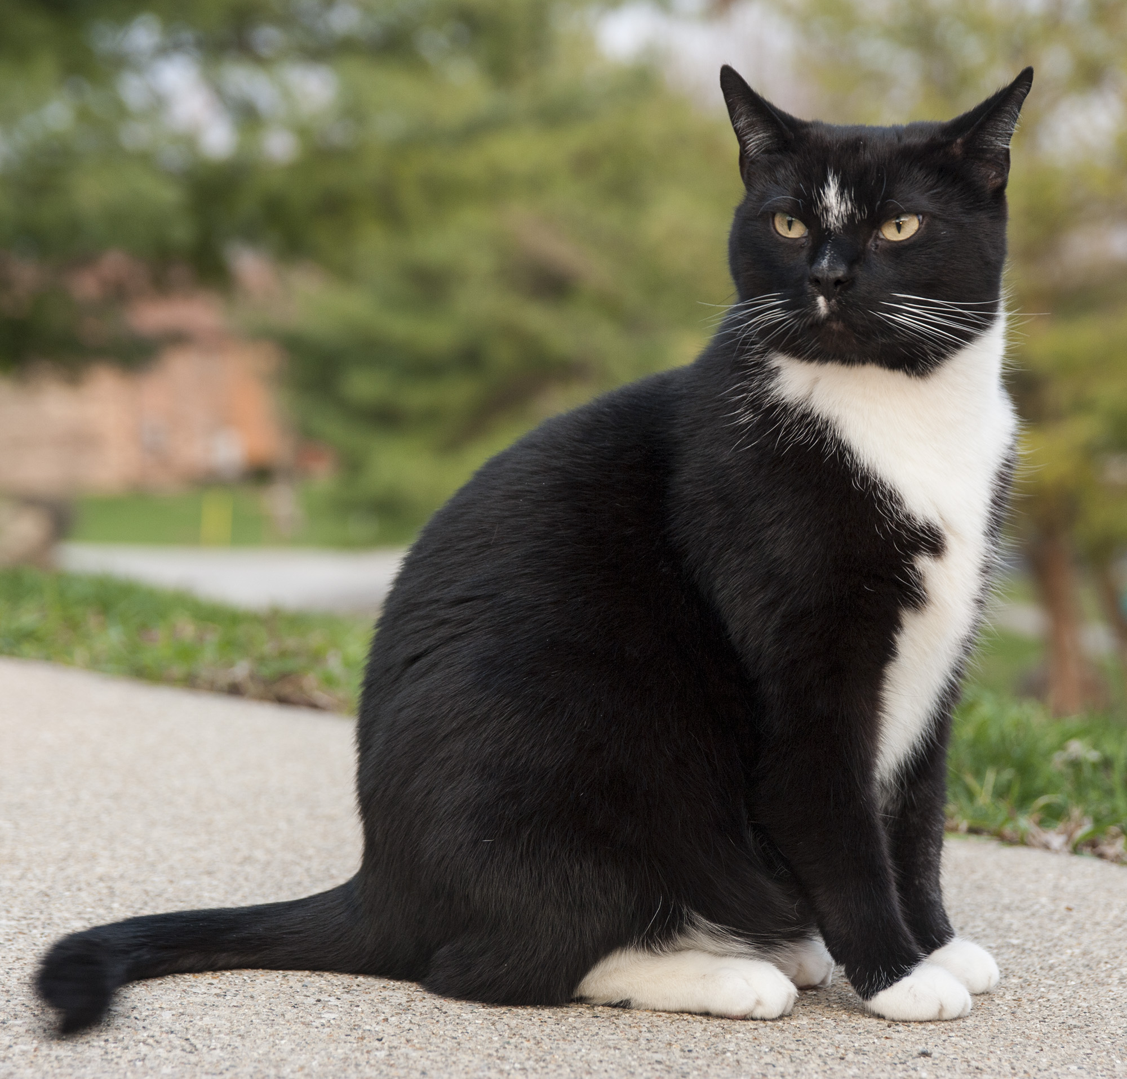
Result：
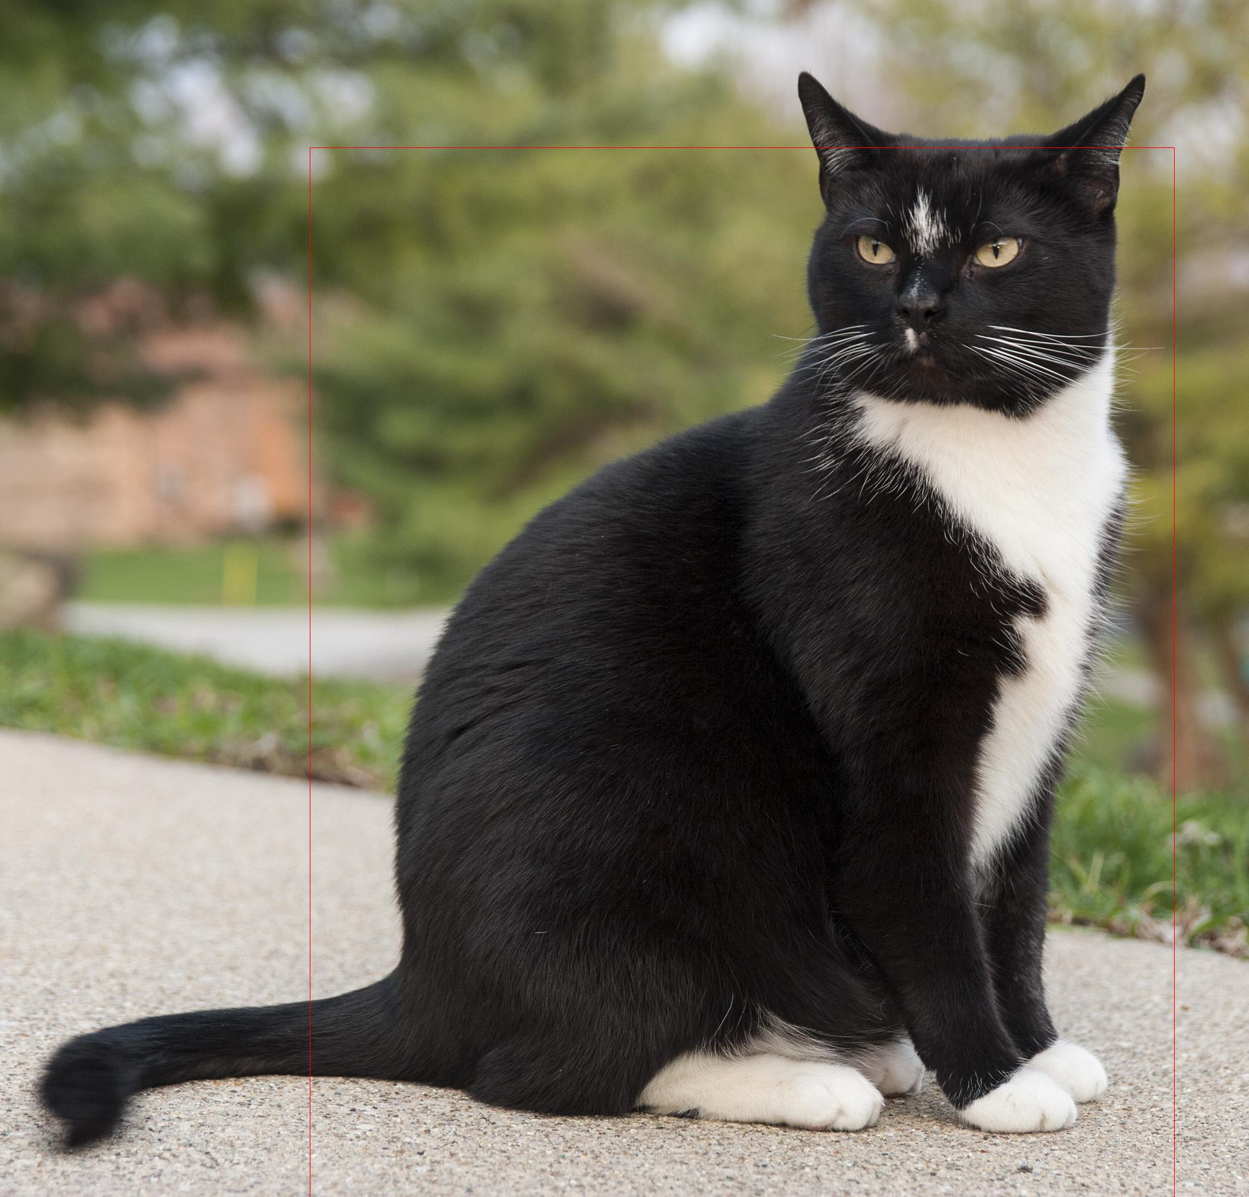
3.机器翻译实验代码
#导入需要的包

import numpy as np

import paddle as paddle

import paddle.fluid as fluid

import os

import paddle.fluid.layers as pd
dict_size = 30000 #字典维度

source_dict_dim = target_dict_dim = dict_size # source_dict_dim:源语言字典维度 target_dict_dim：目标语言字典维度

hidden_dim = 32 #解码中隐层大小

decoder_size = hidden_dim #解码中隐层大小

word_dim = 32 #词向量维度

batch_size = 200 #数据提供器每次读入的数据批次大小

max_length = 8 #生成句子的最大长度

beam_size = 2 #柱宽度

is_sparse = True #代表是否用稀疏更新的标志

model_save_dir = "machine_translation.inference.model"
# *********获取训练数据读取器和测试数据读取器train_reader 和test_reader***************

train_reader = paddle.batch(

paddle.reader.shuffle(

paddle.dataset.wmt14.train(dict_size),buf_size=1000),#dict_size:字典维度 buf_size:乱序时的缓存大小

batch_size=batch_size) #batch_size:批次数据大小

#加载预测的数据

test_reader = paddle.batch(

paddle.reader.shuffle(

paddle.dataset.wmt14.test(dict_size), buf_size=1000),

batch_size=batch_size)
#************************实现编码器*******************************

def encoder():

#输入是一个文字序列，被表示成整型的序列。
#lod_level=1 if the input is sequential data, and otherwise lod_level=0.

src_word_id = pd.data(

name="src_word_id", shape=[1], dtype='int64', lod_level=1)

#将上述编码映射到低维语言空间的词向量

src_embedding = pd.embedding(

input=src_word_id, #输入为独热编码

size=[dict_size, word_dim],#dict_size:字典维度 word_dim：词向量维度

dtype='float32',

is_sparse=is_sparse, #代表是否用稀疏更新的标志

#ParamAttr类代表了参数的各种属性。
#比如learning rate（学习率）, regularization（正则化）, trainable（可训练性）, do_model_average(平均化模型)和参数初始化方法.

param_attr=fluid.ParamAttr(name='vemb')) #可学习的隐藏层权重的参数属性。

#输入门、遗忘门和输出门中对于输入词向量的全连接操作 (Wfx, Wix, Wox, Wcx)
#这些操作不包括在dynamic_lstm运算中，用户在LSTM operator之前选择全连接运算

fc1 = pd.fc(input=src_embedding, size=hidden_dim * 4, act='tanh')

#初始化lstm网络，注意size=hidden_dim*4
#返回：隐藏状态(hidden state)，LSTM神经元状态，两者都是T*D维

lstm_hidden0, lstm_0 = pd.dynamic_lstm(input=fc1, size=hidden_dim * 4)

#完成所有时间步内的lstm计算，得到编码的最终输出

encoder_out = pd.sequence_last_step(input=lstm_hidden0)

return encoder_out
#************************定义训练模式下的解码器*******************************

def train_decoder(context):

#获取目标语言序列

trg_language_word = pd.data(

name="target_language_word", shape=[1], dtype='int64', lod_level=1)

#获取目标语言的词向量

trg_embedding = pd.embedding(

input=trg_language_word,

size=[dict_size, word_dim],#dict_size:字典维度 word_dim：词向量维度

dtype='float32',

is_sparse=is_sparse,

param_attr=fluid.ParamAttr(name='vemb'))

rnn = pd.DynamicRNN()

#定义RNN每一步的运算
with rnn.block():

#current_word不是序列数据，lod_level=0; trg_embedding是序列数据，lod_level=1
current_word = rnn.step_input(trg_embedding)#current_word:当前节点的输入

pre_state = rnn.memory(init=context, need_reorder=True)#pre_state:上个节点的输出

current_state = pd.fc(

input=[current_word, pre_state], size=decoder_size, act='tanh')#得到当前节点的输出

#对可能输出的单词进行打分，再用softmax函数进行归一化得到当前节点的概率

current_score = pd.fc(input=current_state, size=target_dict_dim, act='softmax')

#更新当前节点的输出为上个节点的输出

rnn.update_memory(pre_state, current_state)

rnn.output(current_score)

return rnn()
paddle.enable_static()

#得到编码器

context = encoder()

#得到解码器

rnn_out = train_decoder(context)
#训练标签

label = pd.data(name="target_language_next_word", shape=[1], dtype='int64', lod_level=1)

# 用交叉熵损失函数计算损失，并使用mean算子进行损失规约

cost = pd.cross_entropy(input=rnn_out, label=label)

avg_cost = pd.mean(cost)
#定义优化方法

optimizer= fluid.optimizer.Adagrad(

learning_rate=1e-4,

regularization=fluid.regularizer.L2DecayRegularizer(#正则化函数，L2正则化通过限制参数数值
#来缓解过拟合

regularization_coeff=0.1))

opts = optimizer.minimize(avg_cost)
#*************创建Executor*********************

# 配置运算场所，定义使用CPU还是GPU，使用CPU时use_cuda = False，使用GPU时use_cuda = True

use_cuda = True # 设置为True以使用CUDA
place = fluid.CUDAPlace(0) if use_cuda else fluid.CPUPlace() # 使用GPU设备0

exe = fluid.Executor(place)

# 进行参数初始化

exe.run(fluid.default_startup_program())
#定义数据映射器，feed_list对应数据集里每行的三条数据

feeder = fluid.DataFeeder( place=place,feed_list=[ 'src_word_id',

'target_language_word',

'target_language_next_word'])
## 自行配置合适的EPOCH_NUM数值，并完成训练。
import time

EPOCH_NUM = 1
start_time = time.time()

for pass_id in range(EPOCH_NUM):

# 进行训练

train_cost = 0

for batch_id, data in enumerate(train_reader()): #遍历train_reader迭代器

train_cost = exe.run(program=fluid.default_main_program(), #运行主程序

feed=feeder.feed(data), #喂入一个batch的数据

fetch_list=[avg_cost]) #fetch平均误差

if batch_id % 10 == 0: #每10次batch打印一次训练误差

print('Pass:%d, Batch:%d, Cost:%0.5f, Time:%d' %
(pass_id, batch_id, train_cost[0], time.time()-start_time))

#保存模型
#model_save_dir = "/home/aistudio/data/machinetranslet.inference.model"
#如果保存路径不在就创建

if not os.path.exists(model_save_dir):

os.makedirs(model_save_dir)

print ('save models to %s' % (model_save_dir))

#修改指定的 main_program ，构建一个专门用于预测的 Program，
#然后 executor 把它和所有相关参数保存到 dirname 中。
fluid.io.save_inference_model(model_save_dir, ['src_word_id'], [rnn_out], exe)
###

###预测阶段

###

#导入需要的包

import numpy as np

import paddle as paddle

import paddle.fluid as fluid

import os

import paddle.fluid.layers as pd

dict_size = 30000

source_dict_dim = target_dict_dim = dict_size

hidden_dim = 32

word_dim = 32

batch_size = 2

max_length = 8

beam_size = 2

is_sparse = True

decoder_size = hidden_dim

model_save_dir = "machine_translation.inference.model"

#预测阶段编码器

def encoder():

src_word_id = pd.data(

name="src_word_id", shape=[1], dtype='int64', lod_level=1)

src_embedding = pd.embedding(

input=src_word_id,

size=[dict_size, word_dim],

dtype='float32',

is_sparse=is_sparse,

param_attr=fluid.ParamAttr(name='vemb'))

fc1 = pd.fc(input=src_embedding, size=hidden_dim * 4, act='tanh')

lstm_hidden0, lstm_0 = pd.dynamic_lstm(input=fc1, size=hidden_dim * 4)

encoder_out = pd.sequence_last_step(input=lstm_hidden0)

return encoder_out
paddle.enable_static()

#预测阶段解码器

def decode(context):

init_state = context

#创建一个张量，值为目标序列最大长度max_length
array_len = pd.fill_constant(shape=[1], dtype='int64', value=max_length)

counter = pd.zeros(shape=[1], dtype='int64', force_cpu=True)

# fill the first element with init_state

state_array = pd.create_array('float32')

pd.array_write(init_state, array=state_array, i=counter)

# ids, scores as memory
#用两个array存储生成token的id，以及累计得分

ids_array = pd.create_array('int64')

scores_array = pd.create_array('float32')

#初始id和初始得分
init_ids = pd.data(name="init_ids", shape=[1], dtype="int64", lod_level=2)

init_scores = pd.data(

name="init_scores", shape=[1], dtype="float32", lod_level=2)

#初始id和初始得分写入对应array
pd.array_write(init_ids, array=ids_array, i=counter)

pd.array_write(init_scores, array=scores_array, i=counter)

#生成目标语言长度大于等于max_length则停止解码
cond = pd.less_than(x=counter, y=array_len)
while_op = pd.While(cond=cond)

with while_op.block():

#从对应array中读取上一时刻的id, state, score
pre_ids = pd.array_read(array=ids_array, i=counter)

pre_state = pd.array_read(array=state_array, i=counter)

pre_score = pd.array_read(array=scores_array, i=counter)

# expand the lod of pre_state to be the same with pre_score

pre_state_expanded = pd.sequence_expand(pre_state, pre_score)

pre_ids_emb = pd.embedding(

input=pre_ids,

size=[dict_size, word_dim],

dtype='float32',

is_sparse=is_sparse,

param_attr=fluid.ParamAttr(name='vemb'))

# use rnn unit to update rnn

current_state = pd.fc(

input=[pre_state_expanded, pre_ids_emb],

size=decoder_size,

act='tanh')

current_state_with_lod = pd.lod_reset(x=current_state, y=pre_score)

################################

# use score to do beam search

################################

current_score = pd.fc(

input=current_state_with_lod, size=target_dict_dim, act='softmax')

topk_scores, topk_indices = pd.topk(current_score, k=beam_size)

# calculate accumulated scores after topk to reduce computation cost

accu_scores = pd.elementwise_add(

x=pd.log(topk_scores), y=pd.reshape(pre_score, shape=[-1]), axis=0)

#根据beam_search算法，选出当前时刻得分最高的topk个ids，以及对应得分
selected_ids, selected_scores = pd.beam_search(

pre_ids,

pre_score,

topk_indices,

accu_scores,

beam_size,

end_id=1,

level=0)

#多条件分支语句
with pd.Switch() as switch:

#若所有beam分支的句子都解码结束，设cond=0，终止循环
with switch.case(pd.is_empty(selected_ids)):

pd.fill_constant(

shape=[1], value=0, dtype='bool', force_cpu=True, out=cond)

with switch.default():

pd.increment(x=counter, value=1, in_place=True)

# update the memories

pd.array_write(current_state, array=state_array, i=counter)

pd.array_write(selected_ids, array=ids_array, i=counter)

pd.array_write(selected_scores, array=scores_array, i=counter)

# update the break condition: up to the max length or all candidates of

# source sentences have ended.

length_cond = pd.less_than(x=counter, y=array_len)

finish_cond = pd.logical_not(pd.is_empty(x=selected_ids))

pd.logical_and(x=length_cond, y=finish_cond, out=cond)

#beam_search_decode返回两个LoDTensor，它们lod的level=2，
#这两个level分别表示每个源句有多少个假设，每个假设有多少个id
translation_ids, translation_scores = pd.beam_search_decode(

ids=ids_array, scores=scores_array, beam_size=beam_size, end_id=1)

return translation_ids, translation_scores

def decode_main(use_cuda):

# 配置运算场所，定义使用CPU还是GPU，使用CPU时use_cuda = False，使用GPU时use_cuda = True

place = fluid.CUDAPlace(0) if use_cuda else fluid.CPUPlace()

exe = fluid.Executor(place)

# 进行参数初始化

exe.run(fluid.default_startup_program())

context = encoder()

translation_ids, translation_scores = decode(context)

#该函数从给定 main_program 中取出所有 persistable==True 的变量（即长期变量），
#然后将它们从目录 dirname 中或 filename 指定的文件中加载出来
#注意:有些变量不是参数，但它们对于训练是必要的。因此，调用
#save_params() 和 load_params() 来保存和加载参数是不够的，可以使用
#save_persistables() 和 load_persistables() 代替这两个函数。
fluid.io.load_persistables(executor=exe, dirname=model_save_dir)

#初始id，和初始score
init_ids_data = np.array([0 for _ in range(batch_size)], dtype='int64')

init_scores_data = np.array(

[1. for _ in range(batch_size)], dtype='float32')

init_ids_data = init_ids_data.reshape((batch_size, 1))

init_scores_data = init_scores_data.reshape((batch_size, 1))

init_lod = [1] * batch_size

#lod_level=2
init_lod = [init_lod, init_lod]

init_ids = fluid.create_lod_tensor(init_ids_data, init_lod, place)

init_scores = fluid.create_lod_tensor(init_scores_data, init_lod, place)

test_reader = paddle.batch(

paddle.reader.shuffle(

paddle.dataset.wmt14.test(dict_size), buf_size=1000),

batch_size=batch_size)

feed_order = ['src_word_id']

feed_list = [

#获取变量名为var_name(此处为src_word_id)的变量
fluid.default_main_program().global_block().var(var_name)

for var_name in feed_order

]

feeder = fluid.DataFeeder(feed_list, place)

src_dict, trg_dict = paddle.dataset.wmt14.get_dict(dict_size)

#开始预测结果

for data in test_reader():

#测试阶段feed_dict中的keys包含src_word_id, init_ids, init_scores
feed_data = list(map(lambda x: [x[0]], data))

feed_dict = feeder.feed(feed_data)

feed_dict['init_ids'] = init_ids

feed_dict['init_scores'] = init_scores

results = exe.run(

fluid.default_main_program(),

feed=feed_dict,

fetch_list=[translation_ids, translation_scores],

return_numpy=False)

result_ids = np.array(results[0])

result_ids_lod = results[0].lod()

result_scores = np.array(results[1])

print("Original sentence:")

print(" ".join([src_dict[w] for w in feed_data[0][0][1:-1]]))

print("Translated score and sentence:")

#打印出mini_batch中第一条数据beam_search的beam_size个翻译结果

for i in range(beam_size):

#根据LoD得出每个句子的开始/终置位置下标
start_pos = result_ids_lod[1][i] + 1

end_pos = result_ids_lod[1][i + 1]

print("%d\t%.4f\t%s\n" % (

i + 1, result_scores[end_pos - 1],

" ".join([trg_dict[w] for w in result_ids[start_pos:end_pos]])))

break

def main(use_cuda):

decode_main(use_cuda) # Beam Search does not support CUDA

if __name__ == '__main__':

main(True)

4.机器翻译实验结果（截图）
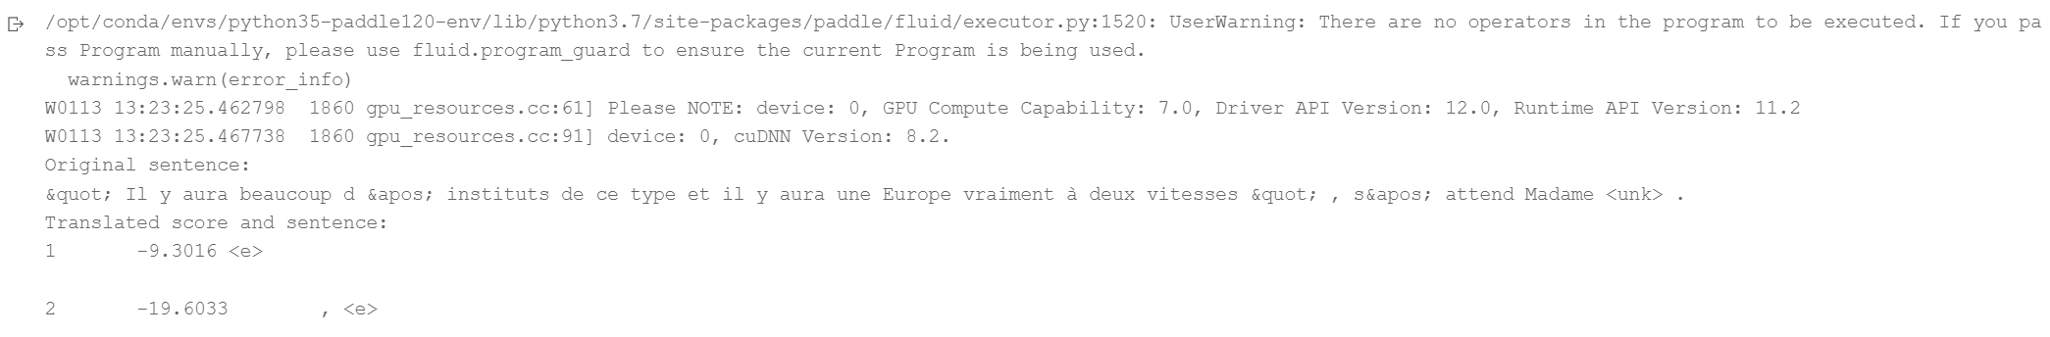
四、延伸实验
谈谈你对本门课程实验的感想。（不少于200字）
通过本门课程的实验，我对深度学习有了更加深入的理解和认识。在实验过程中，我不仅学习了如何使用飞桨框架进行深度学习模型的搭建和训练，更重要的是通过实践加深了对理论知识的理解。
在目标检测实验中，我使用SSD算法完成了对图像中目标的检测任务。通过调整模型参数、设计数据增强策略等过程，我逐步理解了如何优化模型性能。实验过程让我意识到，深度学习不仅需要扎实的理论基础，还需要大量的实践经验来平衡计算资源、训练时间和模型性能之间的关系。
在机器翻译实验中，我实现了基于LSTM的编码器-解码器模型，并运用了Beam Search算法来优化翻译结果。这个过程让我深刻体会到，机器翻译是一个复杂的任务，需要考虑语言的上下文关系和语义连贯性，而不是简单的词语替换。
这些实验经历不仅提升了我的编程能力，更培养了我解决实际问题的思维方式。我认识到在深度学习应用中，数据处理、模型选择、参数调优等每个环节都同等重要。这些经验对我未来在人工智能领域的深入学习和实践都将产生深远的影响。

